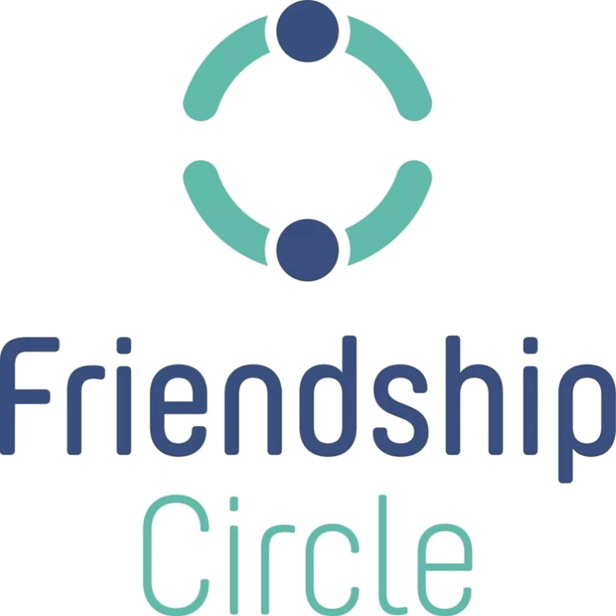

Friendship Circle’s Code of Conduct

Date:

Name:

I will promote the creation of a friendship community based on mutual respect and a sense of personal well-being. I will treat others with honor and respect because we are all created in the image of G-d.

As a volunteer of Friendship Circle:

* I understand that Friendship Circle expects me to behave responsibly. I agree to utilize my best judgment and sense of responsibility when spending time with the child with whom I am matched.
* I understand that the use of a cell phone during a Friendship Circle program is not acceptable and should only be used in case of emergency.
* I agree to respect the privacy of all participants of the Friendship Circle and to keep personal information confidential.
* I understand that once I commit to attend an event, the Friendship Circle staff and special friends expect me to be there. I agree to attend and give it my best effort. In the event that I cannot attend, I agree to give notice to Friendship Circle staff, at least 48 hours in advance.
* If someone gets hurt or some other incident occurs while I am volunteering, it is my responsibility to immediately report the occurrence to Friendship Circle staff.
* I agree to represent the Friendship Circle to the best of my abilities.
* I have carefully read and agree to abide and be bound by all additional rules and policies in the Friendship Circle Handbooks and any additional rules pertinent to specific events.

**I agree to volunteer for Friendship Circle. I grant Friendship Circle permission to use my name, image, likeness, or recording in connection with any promotional materials including, but not limited to, brochures, advertising, and broadcasts. I understand that participation in Friendship Circle activities involves a certain degree of risk and can be physically, mentally, and emotionally demanding. I have carefully considered the risk involved and agree to participate in this activity. I also understand that participation in this activity is entirely voluntary and requires participants to abide by applicable rules and standards of conduct as set forth in the Friendship Circle Handbook, as it may be modified from time to time. I understand that this local Friendship Circle is independently owned, operated and controlled. I release the Friendship Circle and its employees, directors, officers, and volunteers as well as its affiliates and all other organizations associated with Friendship Circle from any and all claims or liability arising out of this participation.**

Full Name of Volunteer [print] ___________________________________________

Volunteer’s Signature: _________________________________________ Date: _____________

***If the participant is under the age of 18, the signature of a parent or guardian is necessary, please sign below:***

Full Name of Parent/Guardian [print] ___________________________________________

__________________________________________________________ Date: ______________

Parent/Guardian Signature